*DOCKER IMAGE

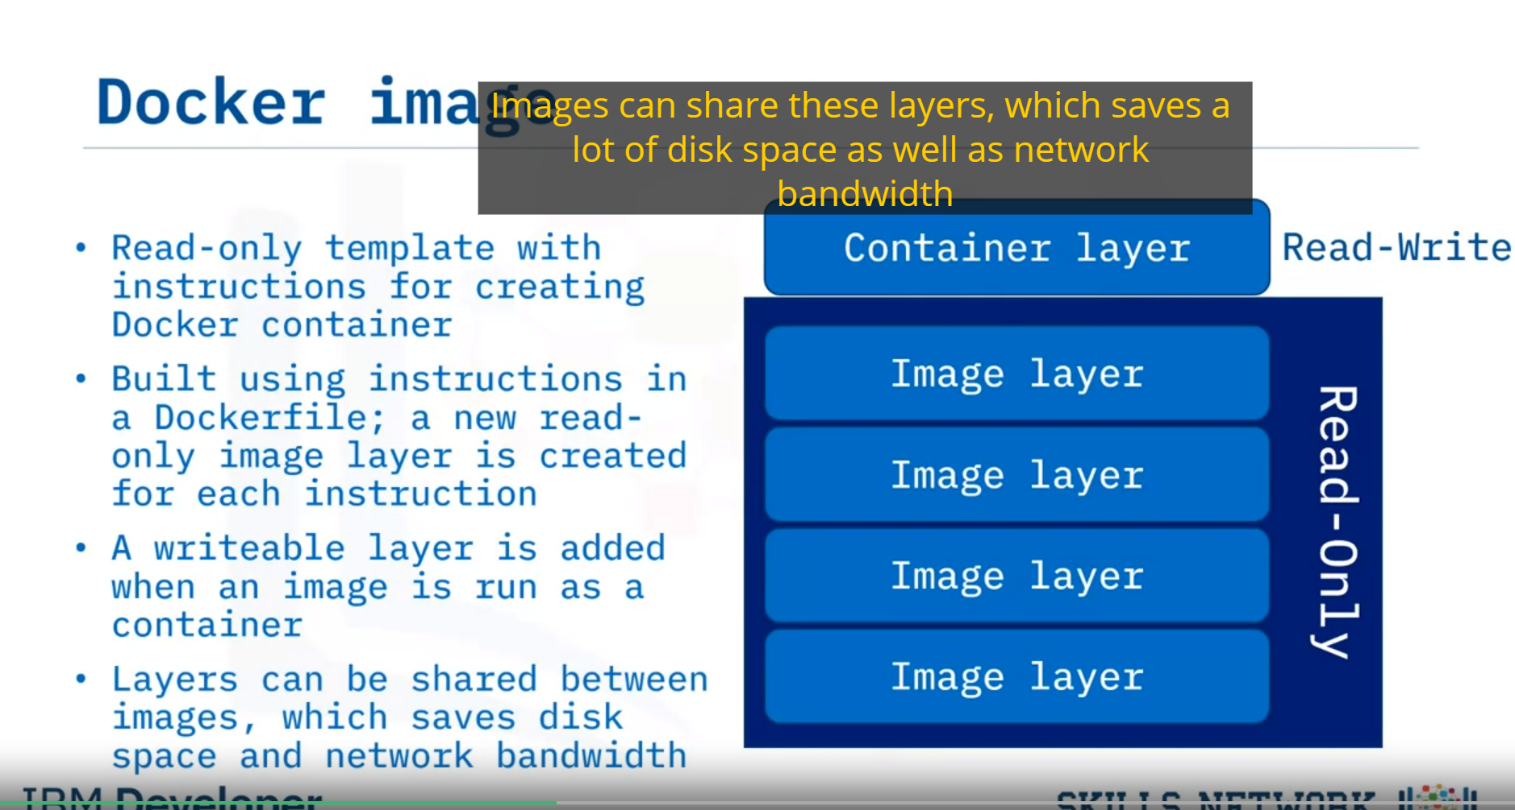

* The writeable layer is needed because containers are not immutable as images
* Image name has a unique format that consists of three parts:

+ hostname/repository:tag

hostname identifies the image registry

A repository is a group of related container images

The tag provides information about a specific version of variant of an image.

*DOCKER CONTAINER

- A docker container is a runnable instance of an image

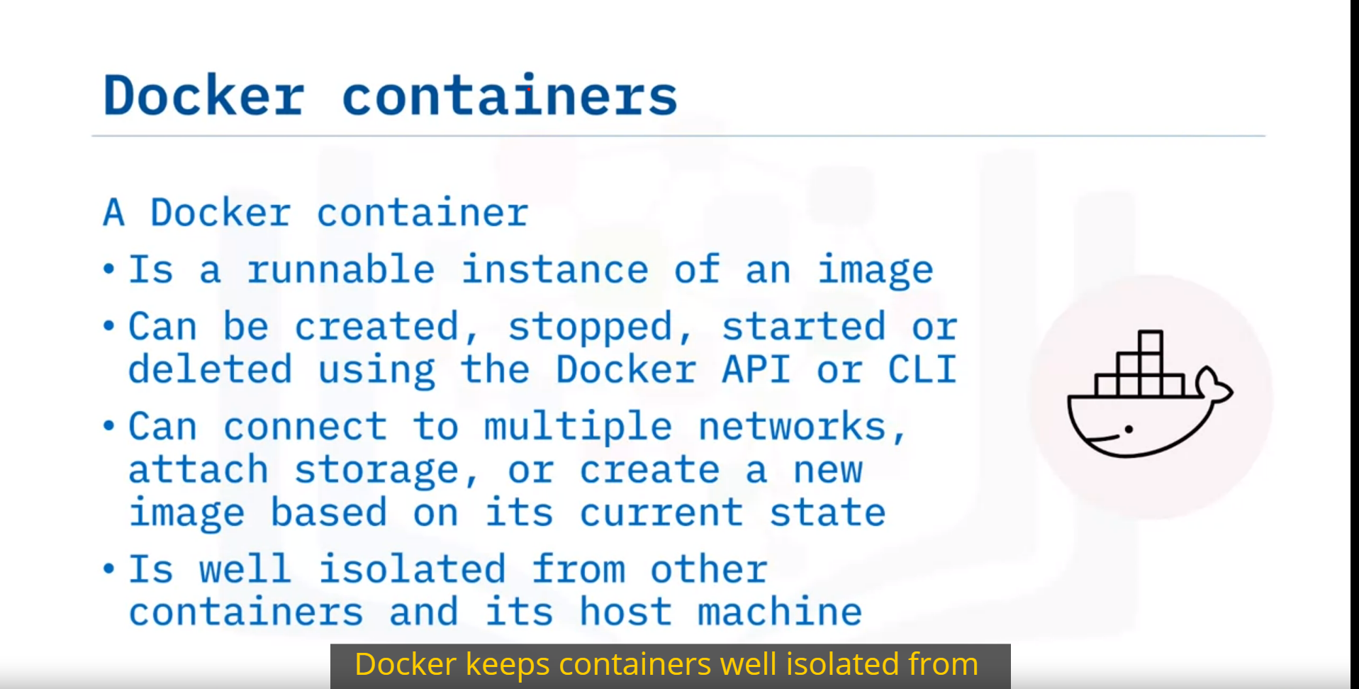

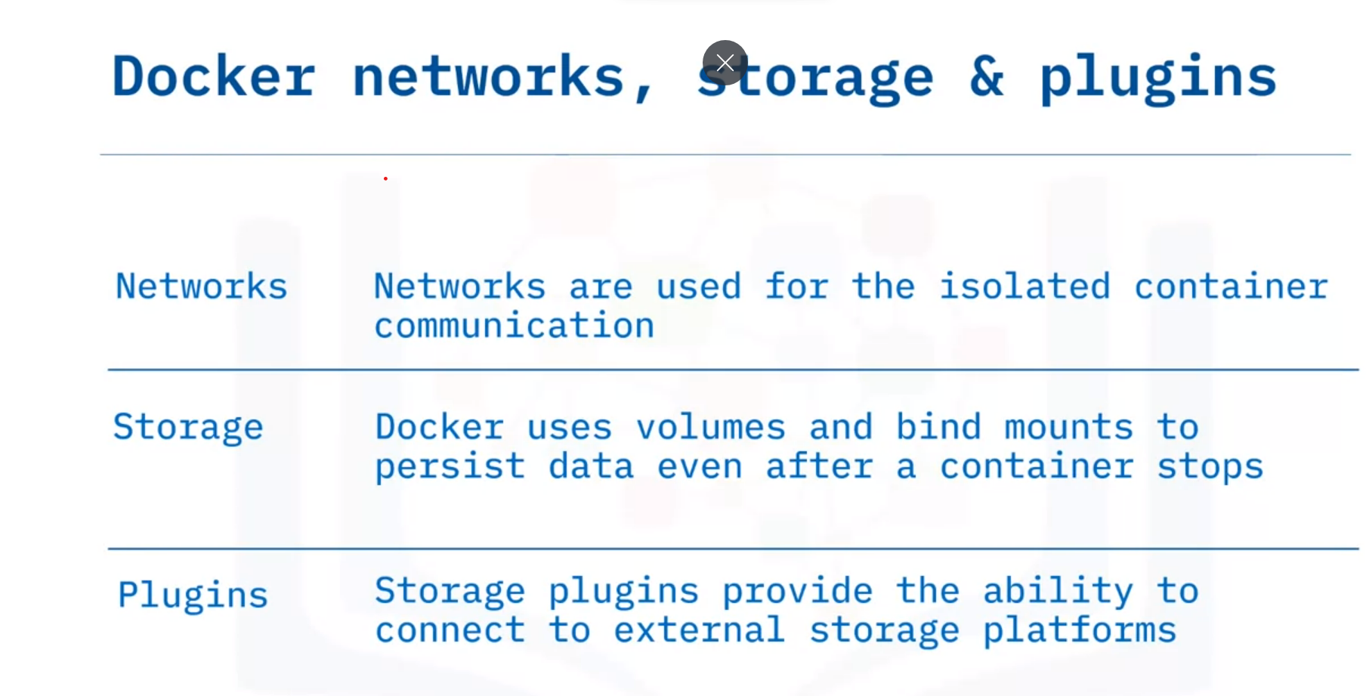

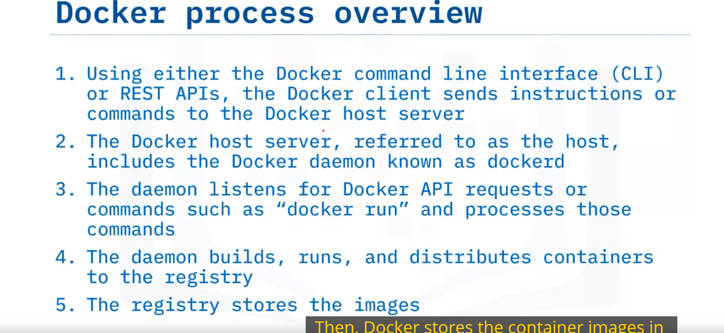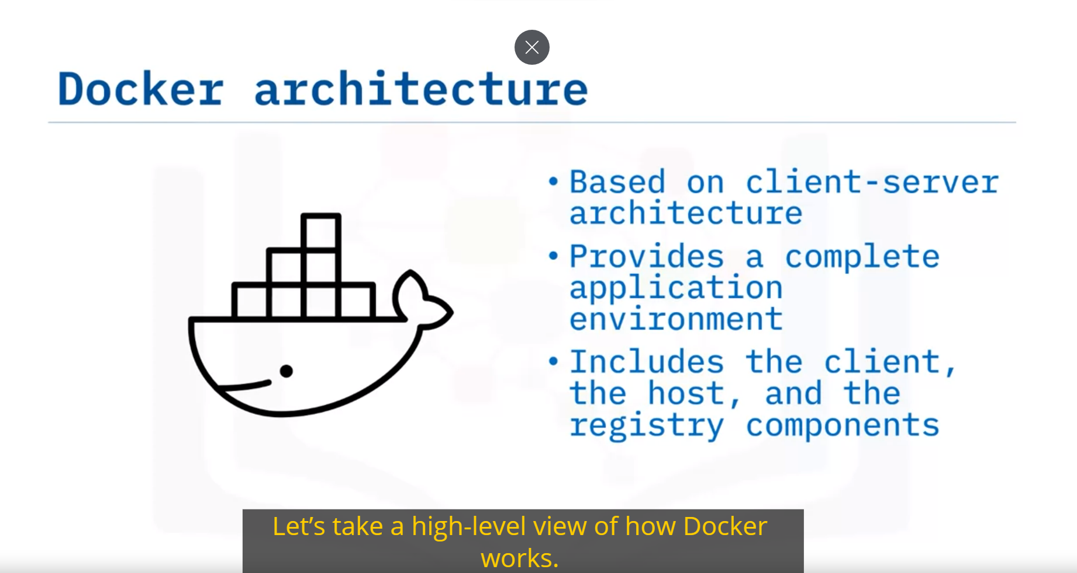

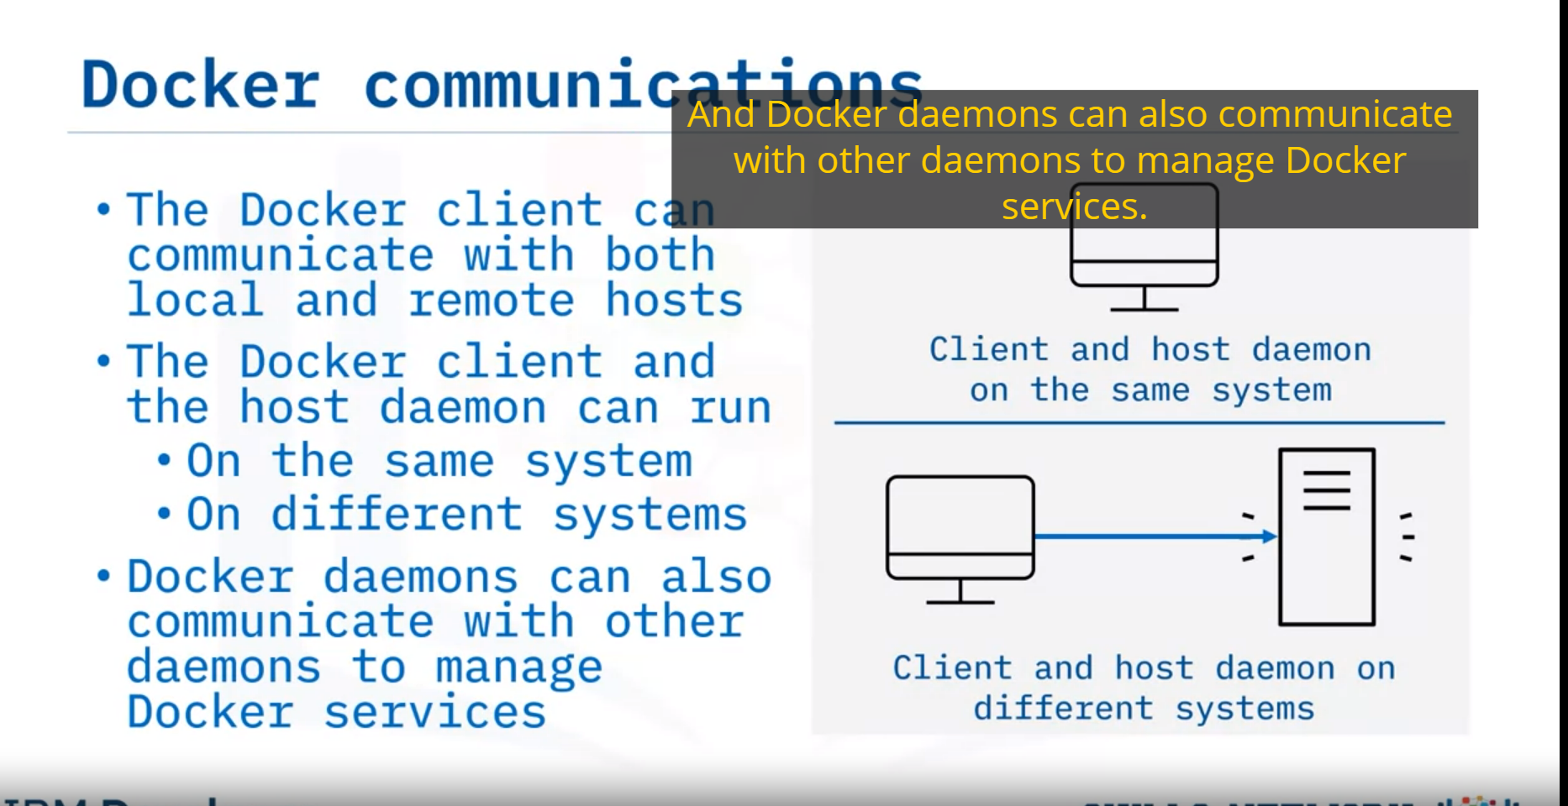

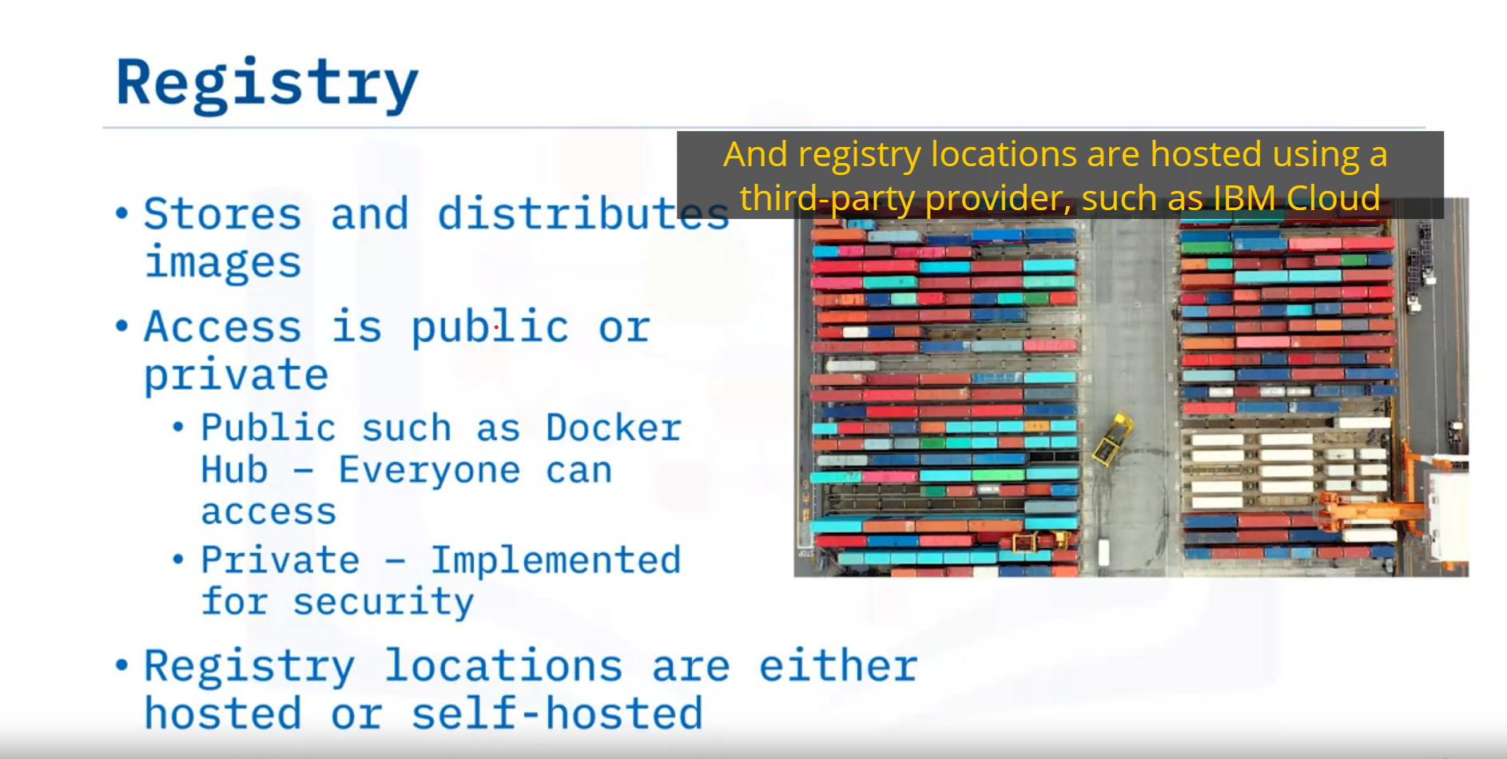

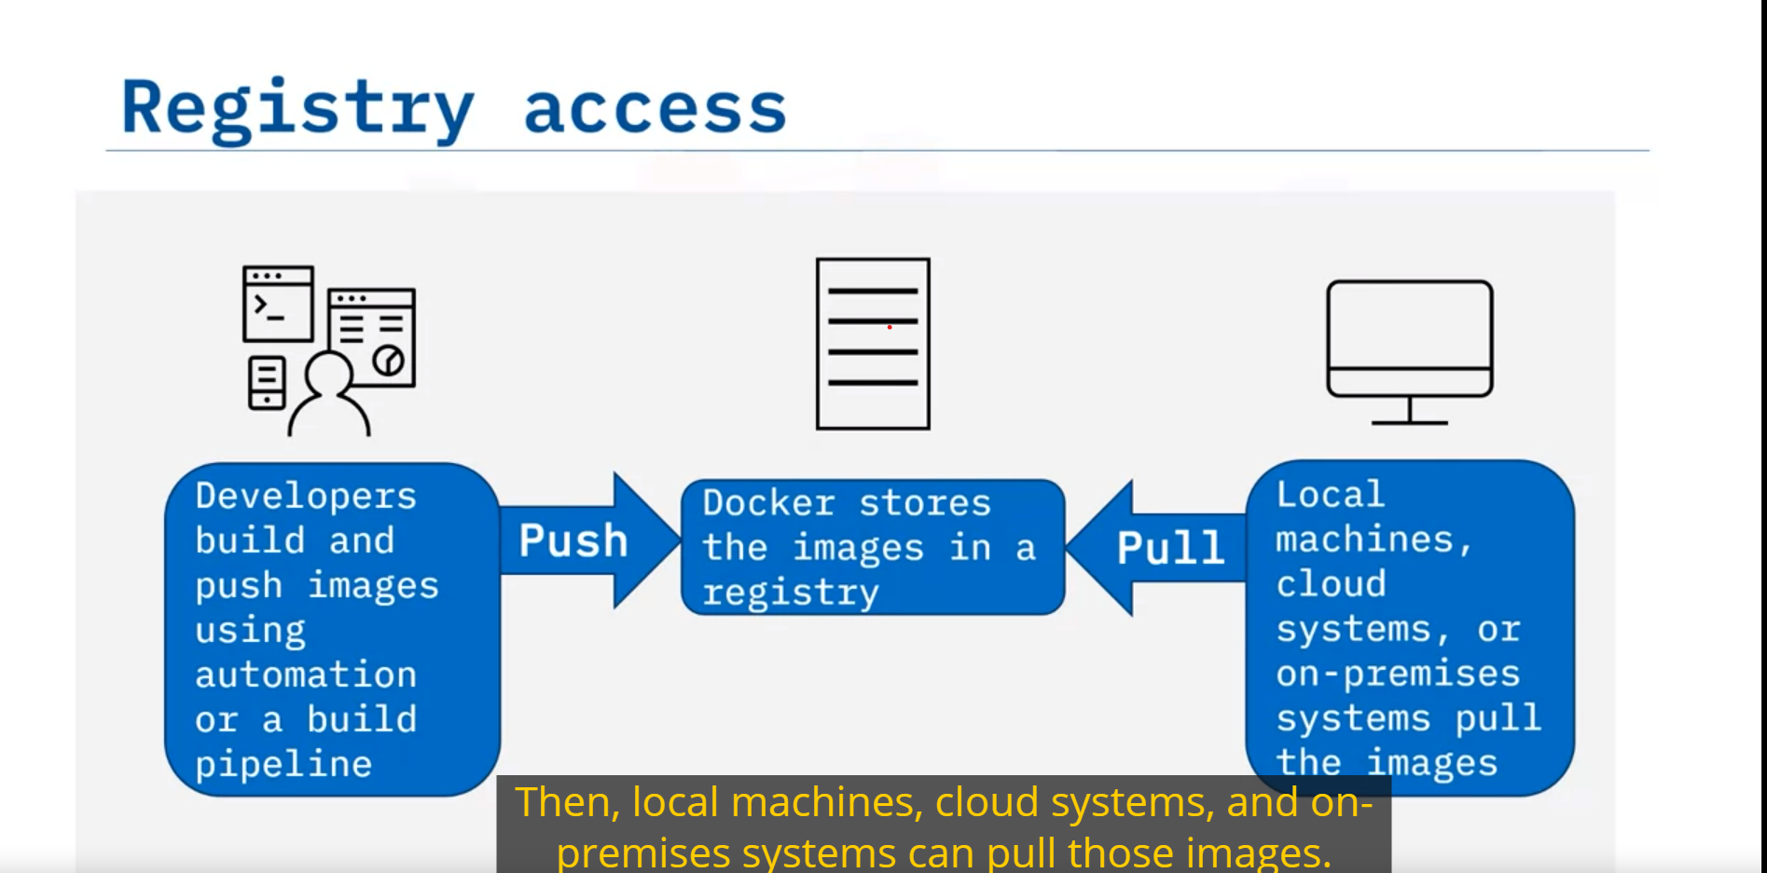

* Docker architecture consists of the Docker client, the Docker host, and the container registry.
* The Docker host contains objects such as the Dockerfiles, images, containers, networks, storage volumes, and other objects, such as plugins and add-ons.
* Docker uses networks to isolate container communications.
* Docker uses volumes and binds mounts to persist data even after a container stops running.
* Plugins, such as storage plugins, provide the ability to connect to external storage platforms

|  |  |
| --- | --- |
| **Command** | **Description** |
| **curl localhost** | Pings the application. |
| **docker build** | Builds an image from a Dockerfile. |
| **docker build . -t** | Builds the image and tags the image id. |
| **docker CLI** | Start the Docker command line interface. |
| **docker container rm** | Removes a container. |
| **docker images** | Lists the images. |
| **docker ps** | Lists the containers. |
| **docker ps -a** | Lists the containers that ran and exited successfully. |
| **docker pull** | Pulls the latest image or repository from a registry. |
| **docker push** | Pushes an image or a repository to a registry. |
| **docker run** | Runs a command in a new container. |
| **docker run -p** | Runs the container by publishing the ports. |
| **docker stop** | Stops one or more running containers. |
| **docker stop $(docker ps -q)** | Stops all running containers. |
| **docker tag** | Creates a tag for a target image that refers to a source image. |
| **docker –version** | Displays the version of the Docker CLI. |
| **exit** | Closes the terminal session. |
| **export MY_NAMESPACE** | Exports a namespace as an environment variable. |
| **git clone** | Clones the git repository that contains the artifacts needed. |
| **ibmcloud cr images** | Lists images in the IBM Cloud Container Registry. |
| **ibmcloud cr login** | Logs your local Docker daemon into IBM Cloud Container Registry. |
| **ibmcloud cr namespaces** | Views the namespaces you have access to. |
| **ibmcloud cr region-set** | Ensures that you are targeting the region appropriate to your cloud account. |
| **ibmcloud target** | Provides information about the account you’re targeting. |
| **ibmcloud version** | Displays the version of the IBM Cloud CLI. |
| **ls** | Lists the contents of this directory to see the artifacts. |